

**CLOUD COMPUTING FINAL PROJECT REPORT**

(End-to-End Deployment of a Cloud-Hosted Application on AWS)

**Course**: Cloud Computing

**Team members:**

1. Muhammad Ahtisham (22i-2690)

2. Anhar Munir (22i-2481)

3. Usman Ghani (22i-8796)

**PROJECT LINKS.**

GitHub Repository: https://github.com/Ahtisham992/photo_gallery.git

Frontend URL: http://photo-gallery.eu-north-1.elasticbeanstalk.com

Backend API URL: http://16.16.65.200:5000

Backend Health Check: http://16.16.65.200:5000/api/health

Contents

1. PROJECT OVERVIEW 5

1.1 Introduction 5

1.2 Project Objectives 5

1.3 Application Description 5

2. APPLICATION ARCHITECTURE 7

2.1 Two-Tier Architecture 7

2.2 Architecture Components 7

2.3 Data Flow 8

3. AWS SERVICES USED 9

4. DATABASE SETUP (AMAZON RDS) 9

4.1 RDS Configuration 9

4.2 Database Endpoint 10

4.3 Database Schema 10

4.4 Security Configuration 11

5. STORAGE SETUP (AMAZON S3) 12

5.1 S3 Bucket Configuration 12

5.2 Bucket Policy 13

5.3 Upload Process 13

6. BACKEND DEPLOYMENT (AMAZON EC2) 14

6.1 EC2 Instance Configuration 14

6.2 Security Group Configuration 15

6.3 Docker Deployment 15

6.4 API Endpoints 16

7. FRONTEND DEPLOYMENT (ELASTIC BEANSTALK) 19

7.1 Elastic Beanstalk Configuration 19

7.2 Deployment Package 19

7.3 Nginx Configuration 20

7.4 Environment Properties 20

8. SECURITY CONFIGURATION 22

8.1 Network Security 22

8.2 Application Security 23

8.3 Data Security 24

9. IAM POLICIES AND ROLES 26

9.1 IAM Role for EC2 26

9.2 IAM User for Development 26

9.3 S3 Bucket Policy 27

9.4 Security Best Practices Followed 27

10. TESTING AND VERIFICATION 29

10.1 Backend API Testing 29

10.2 Frontend Testing 30

10.3 Integration Testing 31

11. CONCLUSION 31

12. SCREENSHOTS 33

# PROJECT OVERVIEW

## 1.1 Introduction

This project demonstrates the end-to-end deployment of a full-stack Photo Gallery application on Amazon Web Services (AWS). The application allows users to register, login, upload photos, organize them into albums, and share them publicly or keep them private.

## 1.2 Project Objectives

• Design and deploy a cloud-native application following AWS best practices

• Implement separate frontend and backend services

• Utilize AWS managed services for database, storage, and hosting

• Apply security best practices including IAM roles and Security Groups

• Demonstrate CRUD operations with a real-world use case

• Ensure public accessibility while maintaining security

## 1.3 Application Description

Photo Gallery is a full-stack web application that provides:

**User Management:**

• User registration with secure password hashing

• JWT-based authentication

• Session management

**Photo Management:**

• Upload photos with metadata (title, description, tags)

• View all public photos or personal photos

• Edit and delete owned photos

• Public/Private visibility settings

**Album Management:**

• Create albums with name, description, and location

• Add photos to albums

• Organize photos by trips, events, or locations

• Public/Private album settings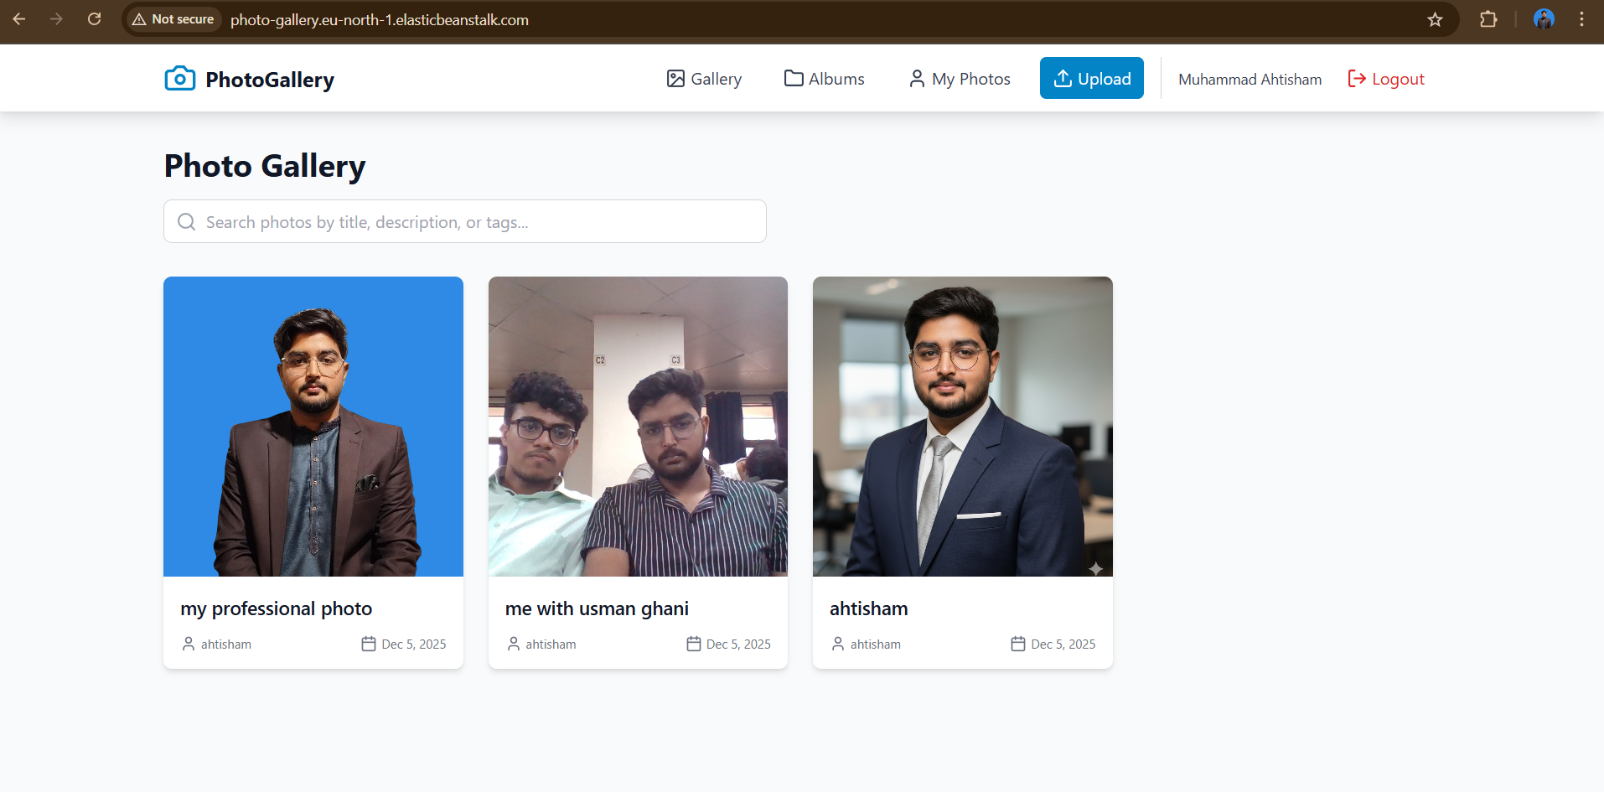 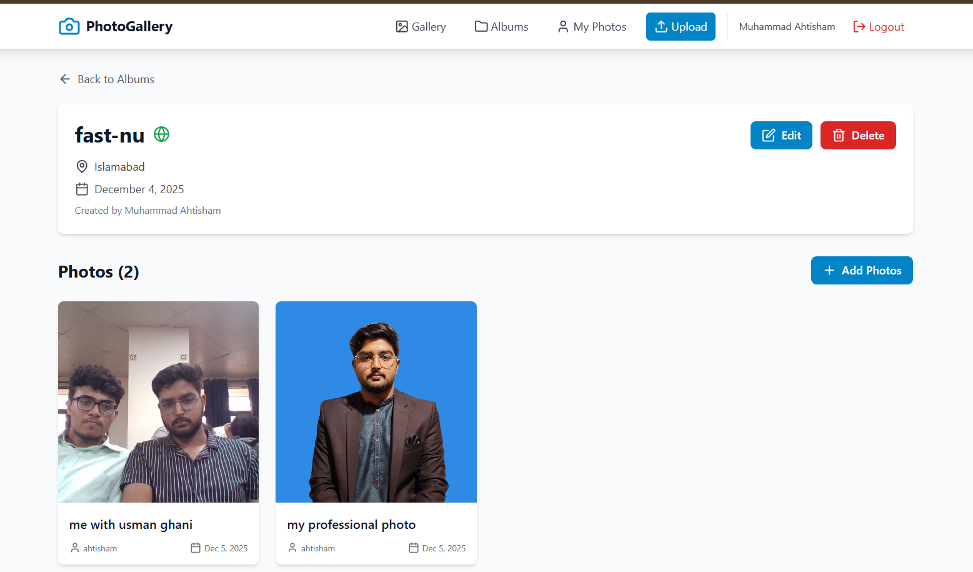

# 2. APPLICATION ARCHITECTURE

## 2.1 Two-Tier Architecture

The application follows a two-tier architecture with clear separation between

presentation and business logic layers:

**Tier 1 - Frontend (Presentation Layer):**

• React-based Single Page Application (SPA)

• Deployed on AWS Elastic Beanstalk

• Handles user interface and user interactions

• Makes REST API calls to backend

**Tier 2 - Backend (Business Logic Layer):**

• Node.js REST API with Express framework

• Deployed on Amazon EC2 using Docker

• Handles authentication, business logic, and data operations

• Communicates with RDS database and S3 storage

## 2.2 Architecture Components

|  |  |  |
| --- | --- | --- |
| **Component** | **Technology** | **AWS Service** |
| Frontend | React + Vite | AWS Elastic Beanstalk |
| Backend | Node.js + Express | Amazon EC2 |
| Database | MySQL | Amazon RDS |
| File Storage | - | Amazon S3 |
| Networking | - | VPC, Security Groups |
| Access Control | - | IAM Roles & policies |

## 2.3 Data Flow

1. User accesses the frontend via Elastic Beanstalk URL

2. Frontend makes REST API calls to the backend on EC2

3. Backend authenticates requests using JWT tokens

4. Backend queries/updates data in RDS MySQL database

5. Photos are uploaded to and retrieved from S3 bucket

6. Response is sent back to the frontend for display

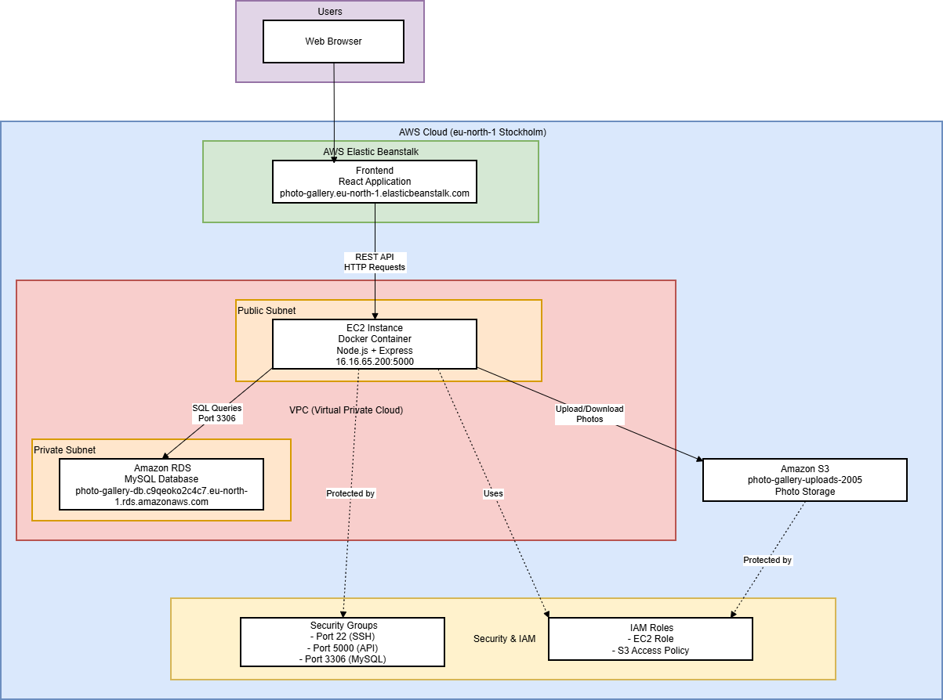

Figure Architecture diagram

# 3. AWS SERVICES USED

|  |  |  |
| --- | --- | --- |
| **Service** | **Configuration** | **Purpose** |
| Amazon EC2  with docker | T2.micro, Amazon Linux 2 | Backend Hosting |
| Amazon RDS service | Db.t3.micro, MySQL 8.0 | Managed Database |
| Amazon S3 | SSC | Photo file storage |
| Elastic Beanstalk | Node.js-20 | Frontend hosting |
| VPC | Default | Network isolation |
| IAM | Roles and policies | Access management |

**Region**: eu-north-1 (Stockholm)

**All services are configured within AWS Free Tier limits to minimize costs.**

# 4. DATABASE SETUP (AMAZON RDS)

## 4.1 RDS Configuration

**Database Engine:** MySQL 8.0.35

**Instance Class:** db.t3.micro (Free Tier eligible)

**Storage**: 20 GB General Purpose SSD (gp2)

**Multi-AZ:** No (Single instance for development)

**Public Access:** No (Private subnet)

**Backup Retention:** 7 days

**Database Name:** photo_gallery

## 4.2 Database Endpoint

**Endpoint:** photo-gallery-db.c9qeoko2c4c7.eu-north-1.rds.amazonaws.com

**Port**: 3306

**Master Username:** admin

## 4.3 Database Schema

The application uses three main tables:

**Users Table:**

• id (Primary Key)

• username

• email (Unique)

• password (Hashed with bcrypt)

• createdAt

• updatedAt

**Photos Table:**

• id (Primary Key)

• title

• description

• filepath

• tags

• isPublic (Boolean)

• userId (Foreign Key)

• albumId (Foreign Key, nullable)

• createdAt

• updatedAt

**Albums Table:**

• id (Primary Key)

• name

• description

• location

• eventDate

• isPublic (Boolean)

• userId (Foreign Key)

• coverPhotoId (Foreign Key, nullable)

• createdAt

• updatedAt

## 4.4 Security Configuration

• Database is placed in a private subnet

• Security Group allows inbound traffic only from EC2 instance

• SSL/TLS encryption enabled for data in transit

• Automated backups enabled

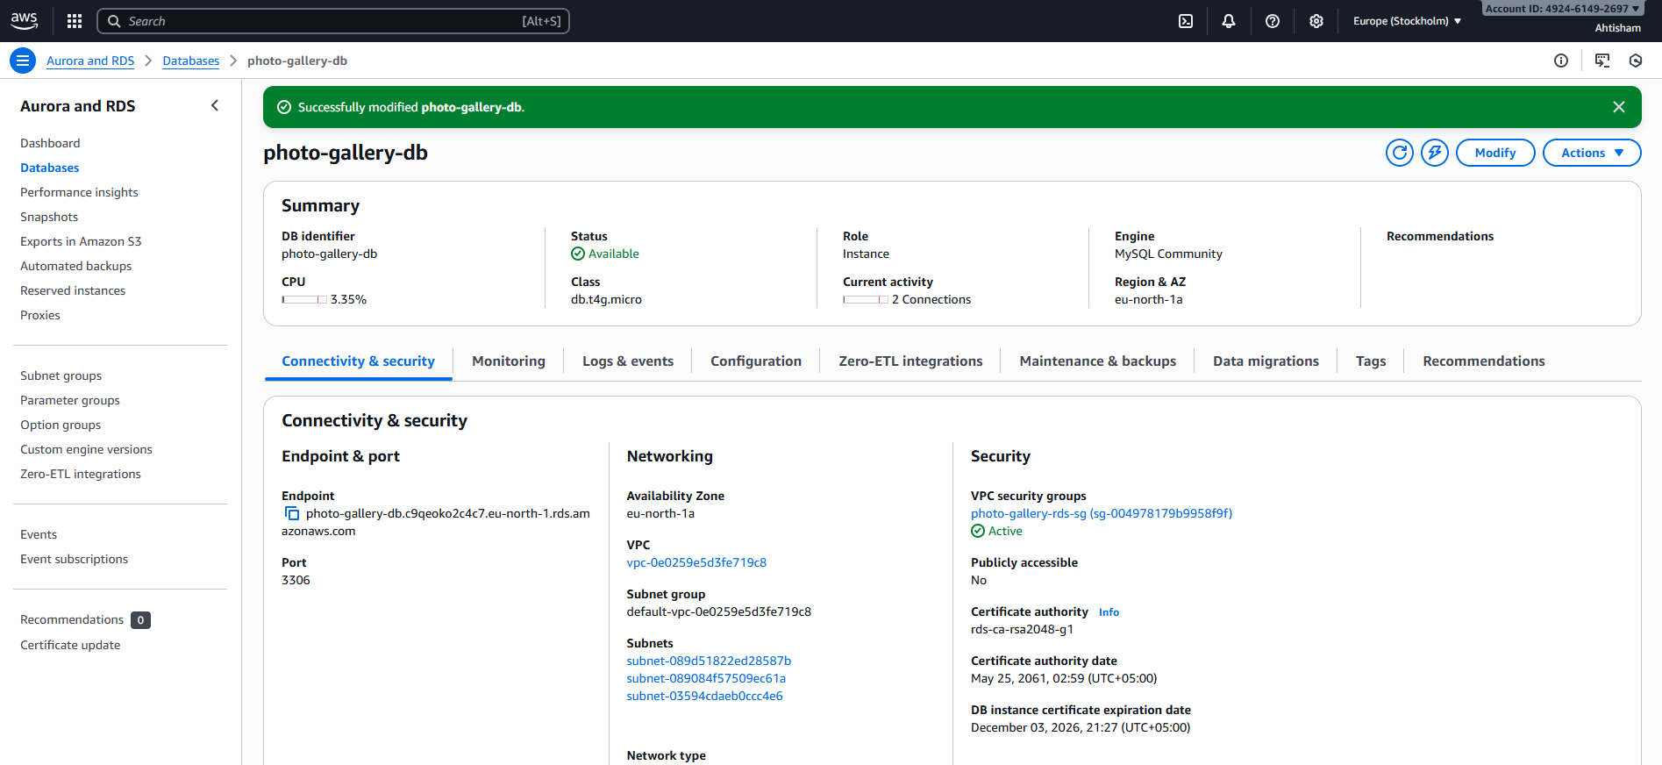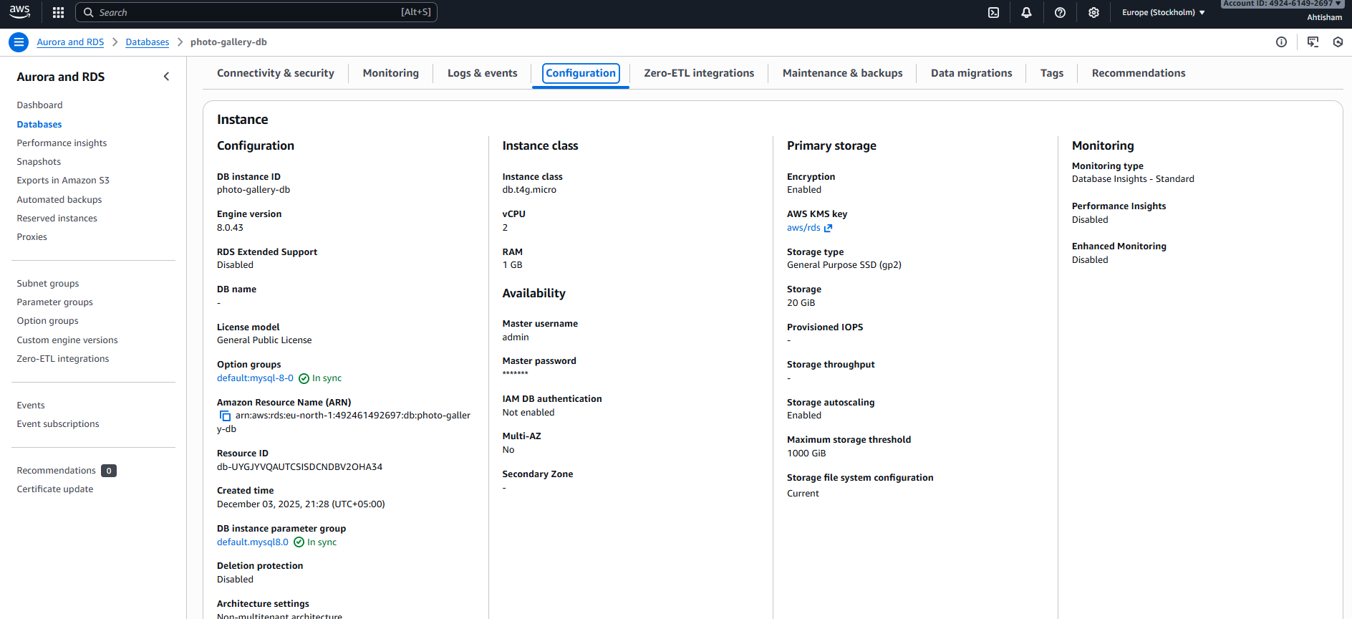

# 5. STORAGE SETUP (AMAZON S3)

## 5.1 S3 Bucket Configuration

**Bucket Name**: photo-gallery-uploads-2005

**Region:** eu-north-1 (Stockholm)

**Storage Class**: S3 Standard

**Versioning:** Disabled

**Encryption:** Server-side encryption (SSE-S3)

## 5.2 Bucket Policy

The bucket is configured with a policy that allows:

• EC2 instance to upload photos (via IAM role)

• Public read access to photo objects

• Restricted write access

## 5.3 Upload Process

1. User uploads photo through frontend

2. Frontend sends multipart form data to backend API

3. Backend validates file (type, size)

4. Backend generates unique filename using UUID

5. Backend uploads to S3 using AWS SDK

6. S3 returns file URL

7. Backend saves photo metadata to RDS with S3 URL

8. Frontend displays uploaded photo

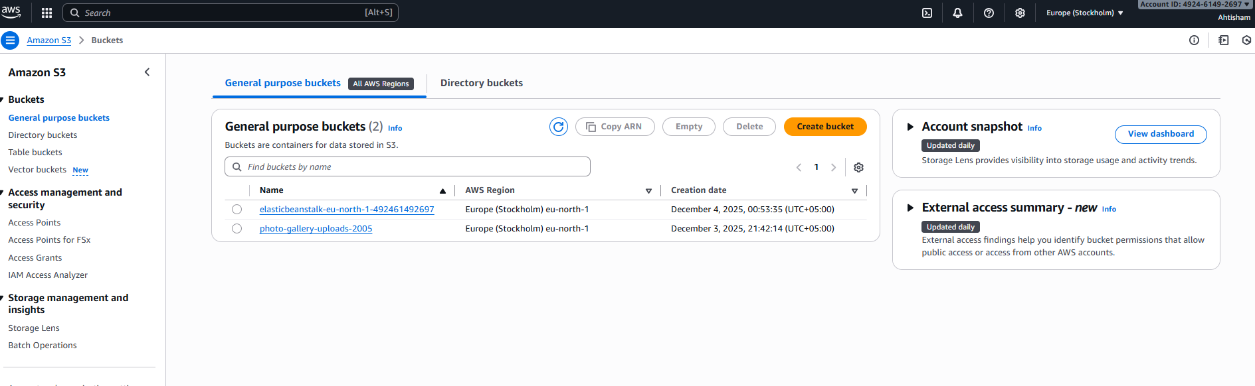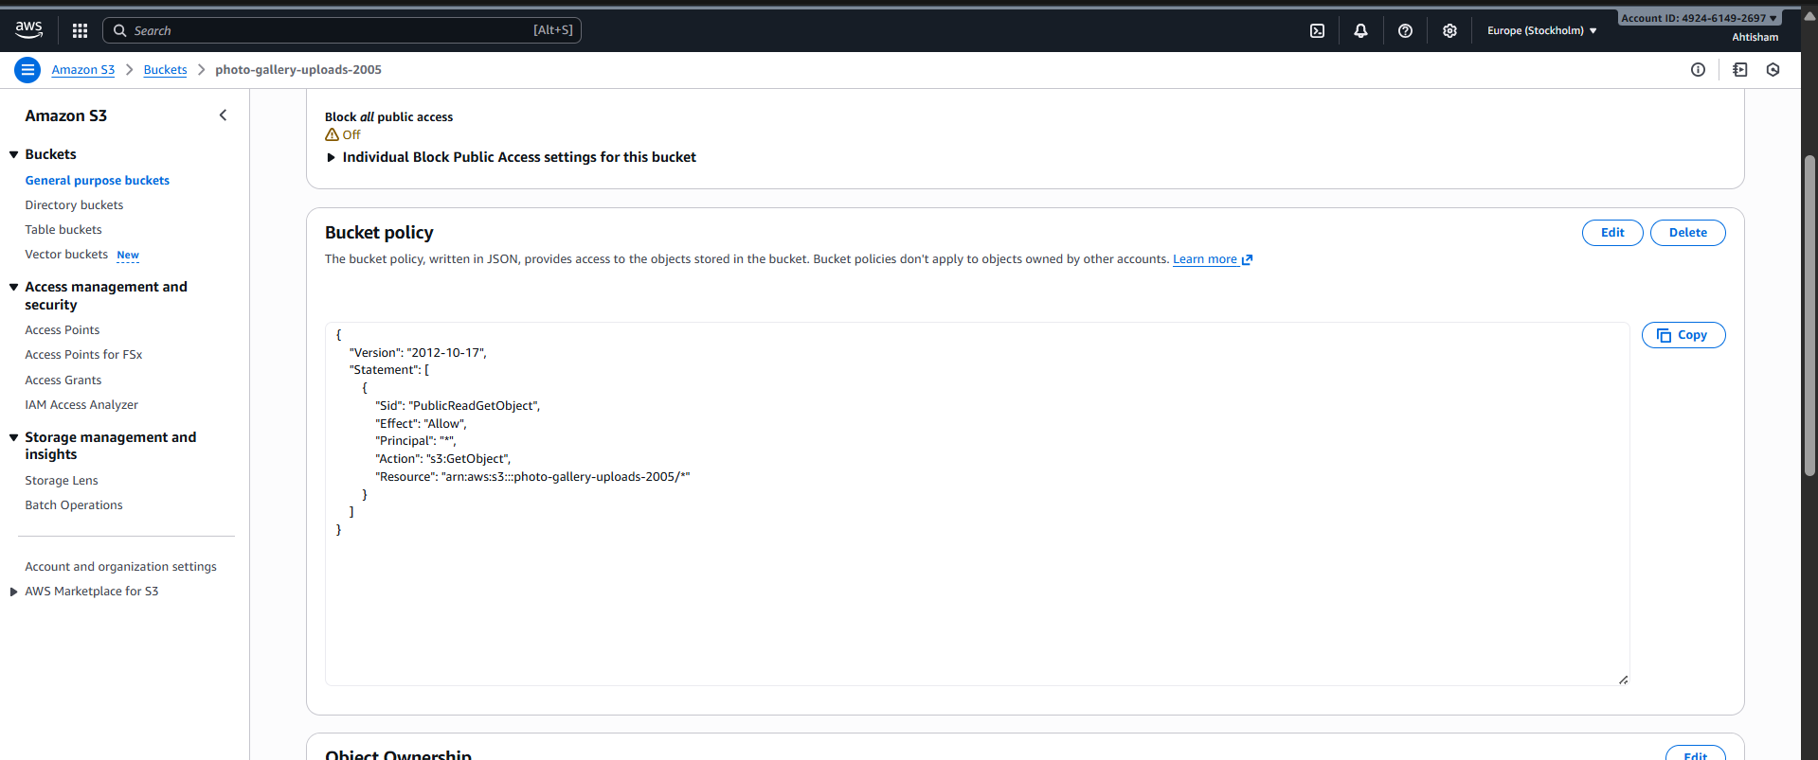

# 6. BACKEND DEPLOYMENT (AMAZON EC2)

## 6.1 EC2 Instance Configuration

**Instance Type:** t2.micro (Free Tier eligible)

**AMI**: Amazon Linux 2023

**vCPUs**: 1

**Memory: 1 GB**

**Storage**: 8 GB EBS (gp2)

**Public IP**: 16.16.65.200

**Region**: eu-north-1 (Stockholm)

## 6.2 Security Group Configuration

**Inbound Rules:**

• SSH (Port 22) - Source: My IP (for management)

• Custom TCP (Port 5000) - Source: 0.0.0.0/0 (for API access)

**Outbound Rules:**

• All traffic allowed

## 6.3 Docker Deployment

The backend is containerized using Docker for consistency and portability.

**Dockerfile Configuration:**

• Base Image: node:18-alpine

• Working Directory: /app

• Dependencies: Installed via npm

• Exposed Port: 5000

• Start Command: npm start

**Docker Run Command:**

docker run -d \

--name photo-gallery-api \

-p 5000:5000 \

-e NODE_ENV=production \

-e DB_HOST=photo-gallery-db.c9qeoko2c4c7.eu-north-1.rds.amazonaws.com \

-e DB_USER=admin \

-e DB_PASSWORD=[password] \

-e DB_NAME=photo_gallery \

-e USE_S3=true \

-e S3_BUCKET_NAME=photo-gallery-uploads-2005 \

--restart unless-stopped \

photo-gallery-backend

## 6.4 API Endpoints

Authentication:

• POST /api/auth/register - User registration

• POST /api/auth/login - User login

• GET /api/auth/me - Get current user

Photos:

• GET /api/photos - Get all photos

• GET /api/photos/:id - Get single photo

• POST /api/photos - Upload photo

• PUT /api/photos/:id - Update photo

• DELETE /api/photos/:id - Delete photo

Albums:

• GET /api/albums - Get all albums

• GET /api/albums/:id - Get single album

• POST /api/albums - Create album

• PUT /api/albums/:id - Update album

• DELETE /api/albums/:id - Delete album

• POST /api/albums/:id/photos/:photoId - Add photo to album

• DELETE /api/albums/:id/photos/:photoId - Remove photo from album

Health Check:

• GET /api/health - Backend health status

**6.5 Environment Variables**

All sensitive configuration is stored in environment variables:

• Database credentials

• JWT secret key

• AWS credentials (via IAM role)

• S3 bucket name

• Node environment

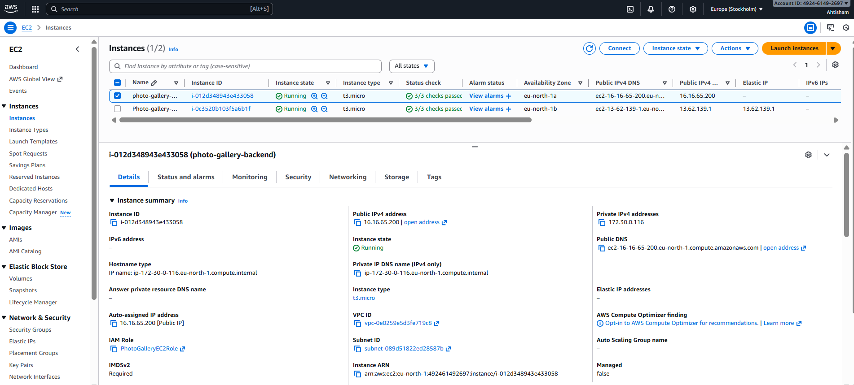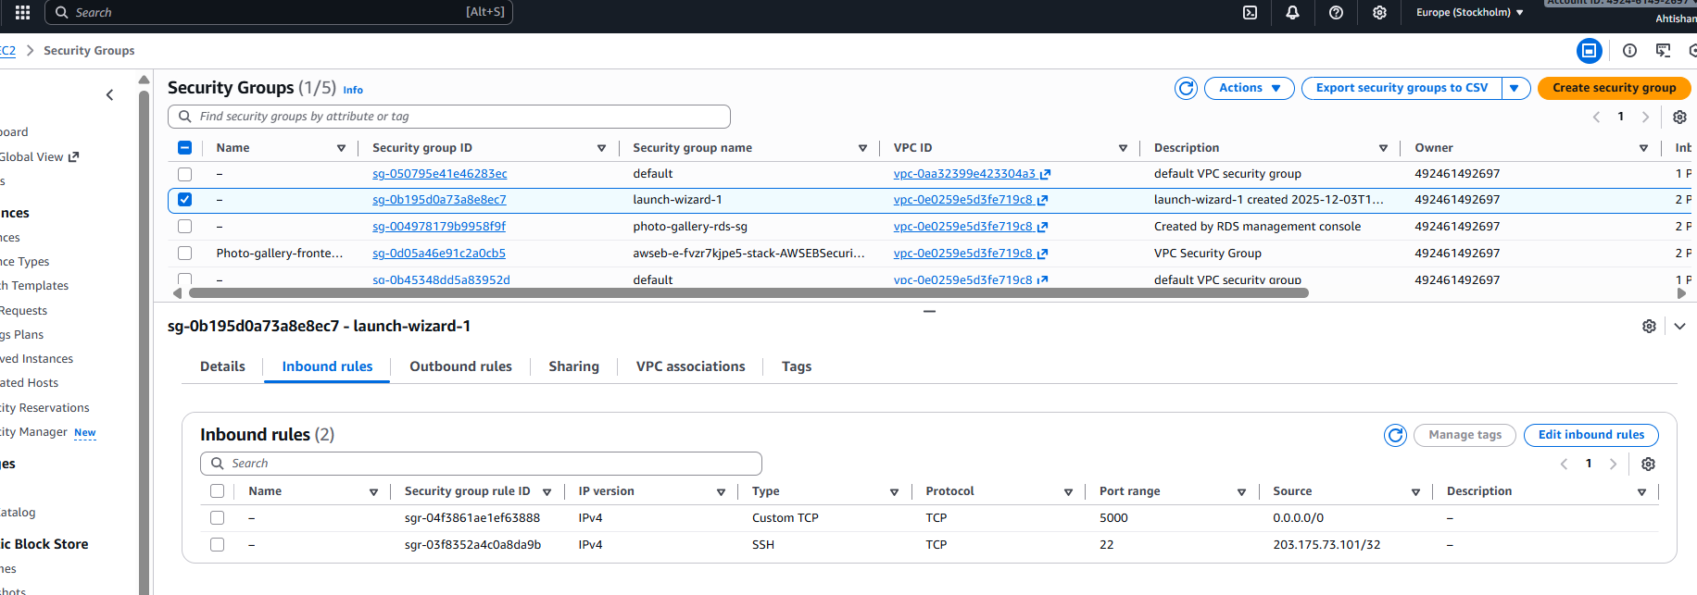

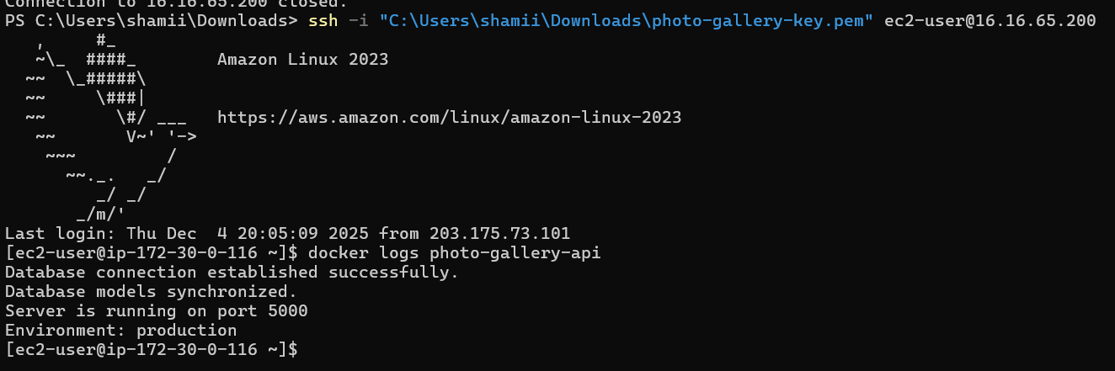

# 7. FRONTEND DEPLOYMENT (ELASTIC BEANSTALK)

## 7.1 Elastic Beanstalk Configuration

**Application Name:** photo-gallery-frontend

**Environment Name:** Photo-gallery-frontend-env

**Platform**: Node.js 20 running on 64bit Amazon Linux 2023

**Platform Version:** 6.7.0

**Instance Type:** t2.micro (Free Tier eligible)

**Environment URL:** photo-gallery.eu-north-1.elasticbeanstalk.com

## 7.2 Deployment Package

The frontend is built and packaged for deployment:

**Build Process:**

1. npm run build (creates optimized production build)

2. Creates build/ directory with static files

3. Adds package.json with serve dependency

4. Adds .ebextensions/ for Nginx configuration

5. Packages into deploy.zip

**Package Contents:**

• index.html

• assets/ (JS and CSS files)

• package.json (with serve script)

• .ebextensions/00_nginx.config (SPA routing)

## 7.3 Nginx Configuration

Custom Nginx configuration for React Router:

• Serves all routes through index.html

• Enables client-side routing

• Prevents 404 errors on page refresh

## 7.4 Environment Properties

• VITE_API_URL: http://16.16.65.200:5000 (Backend URL)

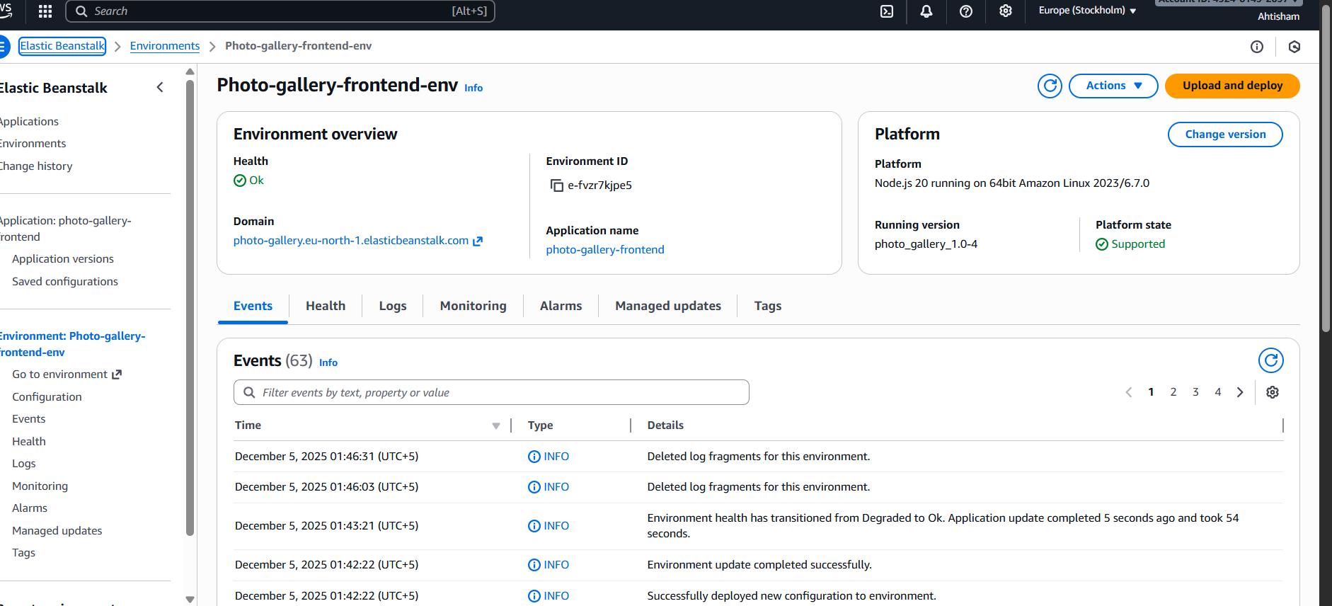

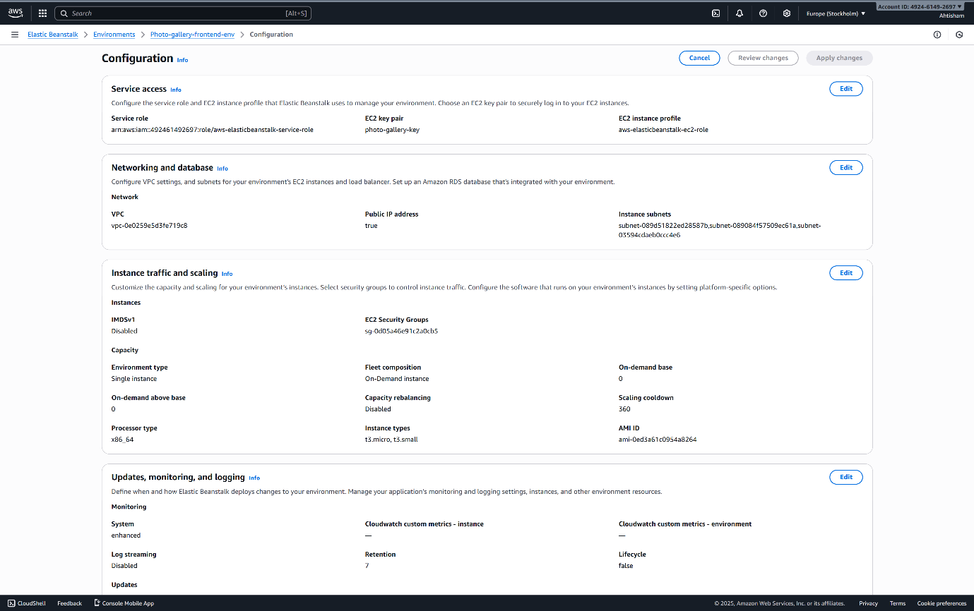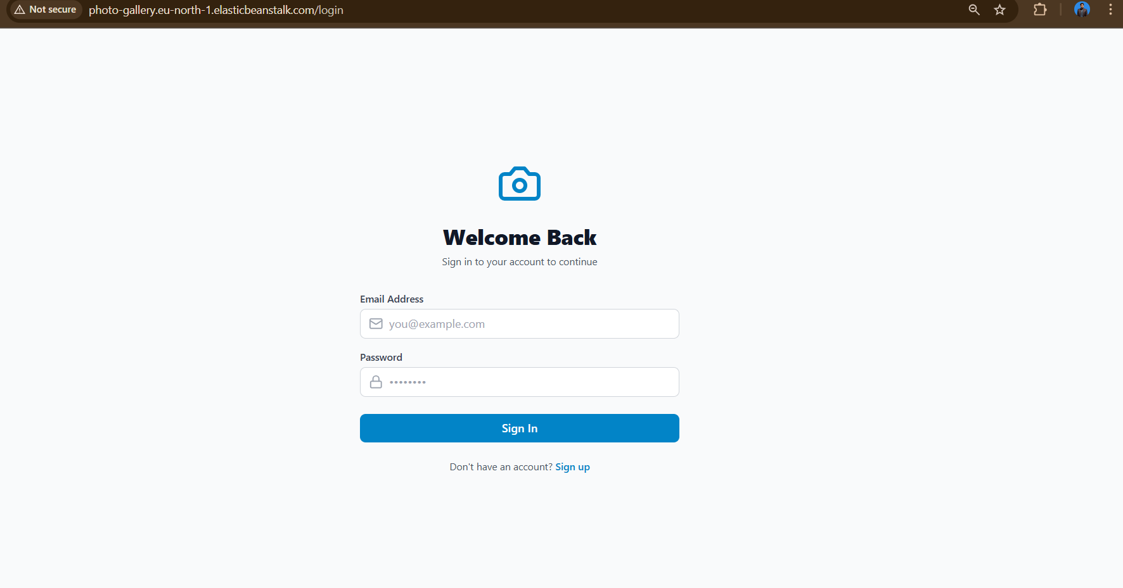

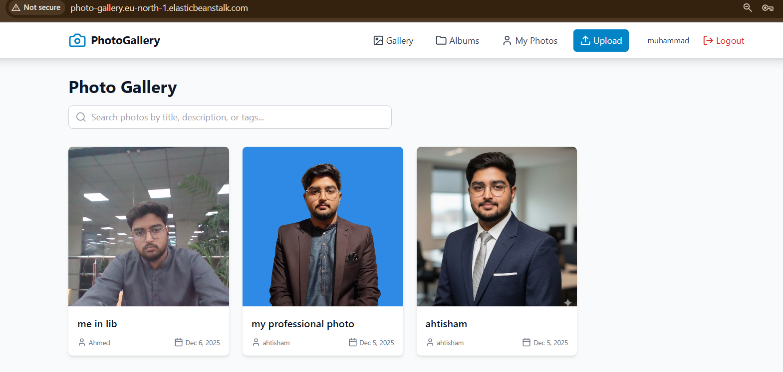

# 8. SECURITY CONFIGURATION

## 8.1 Network Security

**VPC Configuration:**

• Created new VPC for the deployment

• Public subnet for EC2 and Elastic Beanstalk

• Private subnet for RDS database

• Internet Gateway for public access

• Route tables configured appropriately

**Security Groups:**

**1. EC2 Security Group:**

• Inbound: SSH (22), HTTP (5000)

• Outbound: All traffic

**2. RDS Security Group:**

• Inbound: MySQL (3306) from EC2 security group only

• Outbound: All traffic

**3. Elastic Beanstalk Security Group:**

• Inbound: HTTP (80), HTTPS (443)

• Outbound: All traffic

## 8.2 Application Security

Authentication:

• JWT (JSON Web Tokens) for stateless authentication

• Tokens expire after 24 hours

• Secure password hashing using bcrypt (10 salt rounds)

Authorization:

• Protected routes require valid JWT token

• Users can only modify their own photos and albums

• Public/private access control for photos and albums

Input Validation:

• Server-side validation for all inputs

• File type validation (only images allowed)

• File size limits (5MB maximum)

• SQL injection prevention via Sequelize ORM

CORS Configuration:

• Configured to allow requests from Elastic Beanstalk URL

• Credentials enabled for cookie-based sessions

## 8.3 Data Security

• Database credentials stored in environment variables

• RDS in private subnet (not publicly accessible)

• SSL/TLS encryption for data in transit

• S3 server-side encryption for data at rest

• No sensitive data in source code or Git repository

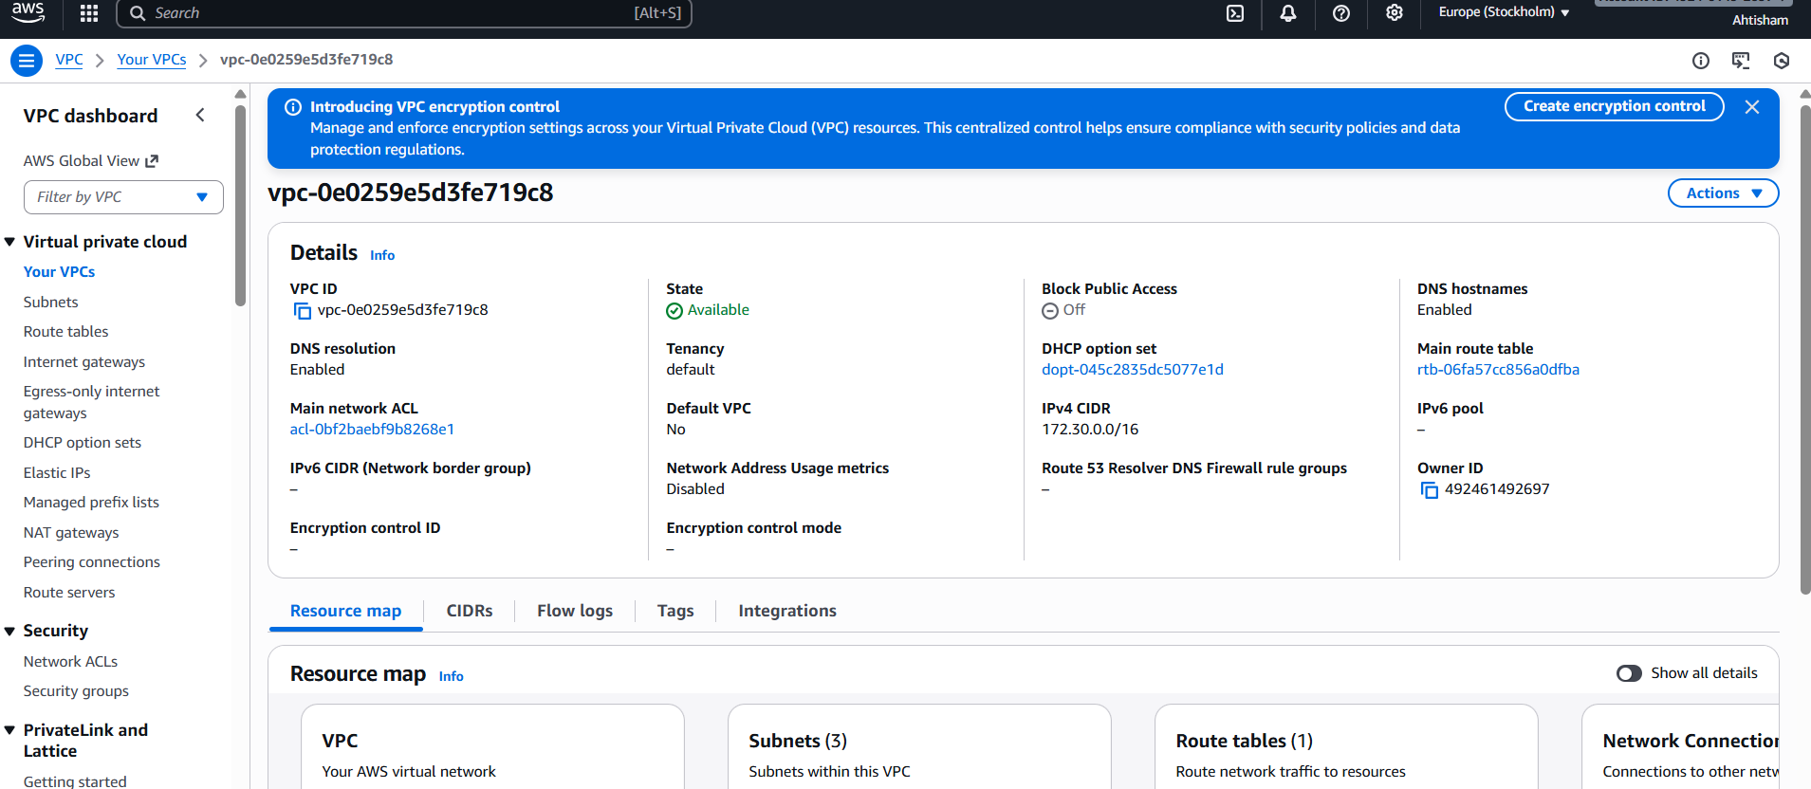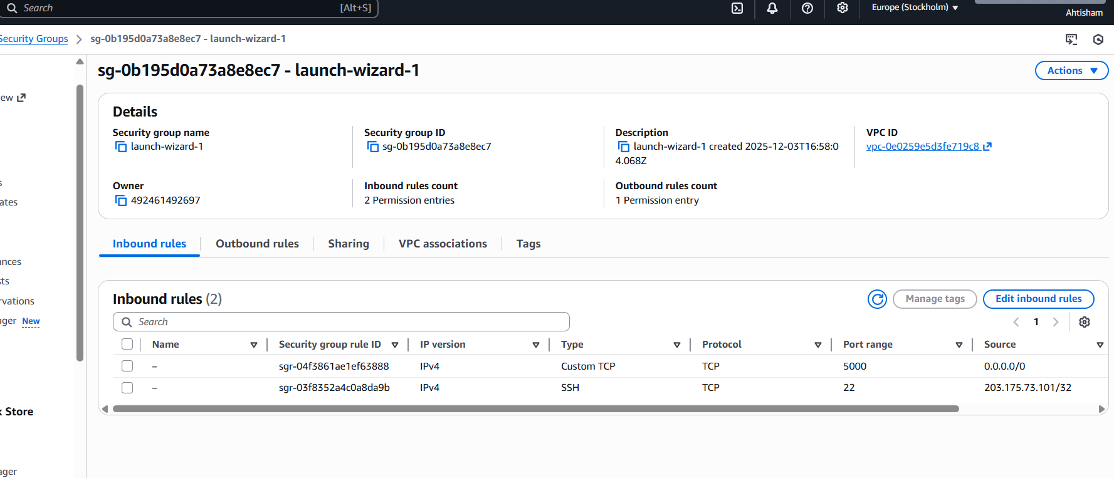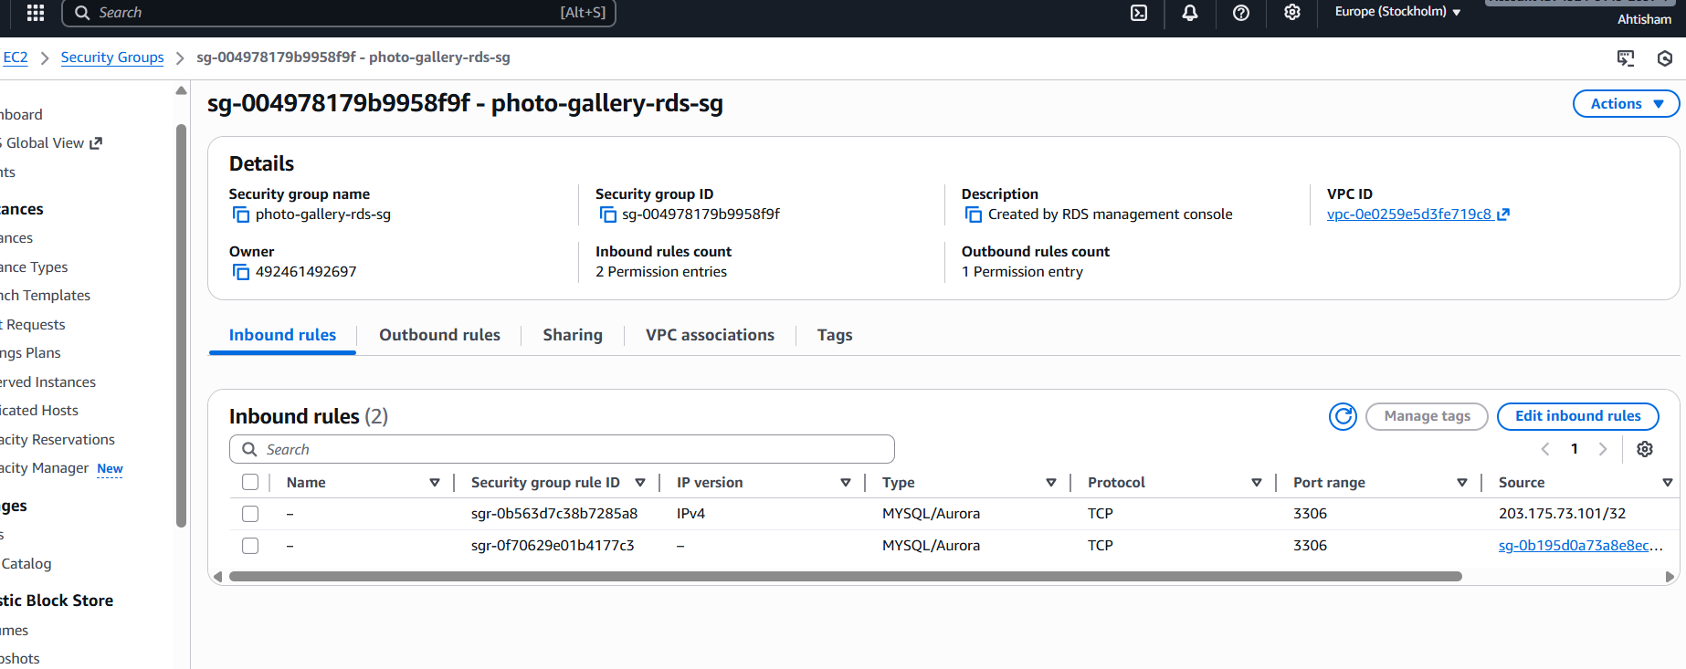

# 9. IAM POLICIES AND ROLES

## 9.1 IAM Role for EC2

**Role Name**: EC2-S3-Access-Role

**Purpose**: Allow EC2 instance to access S3 bucket for photo uploads

**Attached Policies:**

**1. AmazonS3FullAccess (AWS Managed Policy)**

• Allows full access to S3 buckets

• Used for uploading and retrieving photos

**Trust Relationship:**

• Service: ec2.amazonaws.com

• Allows EC2 service to assume this role

## 9.2 IAM User for Development

**User Name**: photo-gallery-admin

**Purpose**: Development and deployment access

**Attached Policies:**

• AmazonEC2FullAccess

• AmazonRDSFullAccess

• AmazonS3FullAccess

• ElasticBeanstalkFullAccess

**Access Keys:**

• Access Key ID: AKIA... (stored securely)

• Secret Access Key: (stored securely, not in code)

## 9.3 S3 Bucket Policy

**Policy allows:**

• EC2 instance (via IAM role) to upload objects

• Public read access to photo objects

• Denies public write access

## 9.4 Security Best Practices Followed

✓ Principle of least privilege applied

✓ No hardcoded credentials in source code

✓ Environment variables for sensitive data

✓ IAM roles used instead of access keys where possible

✓ Regular rotation of access keys

✓ MFA enabled on root account

✓ CloudWatch logging enabled for monitoring

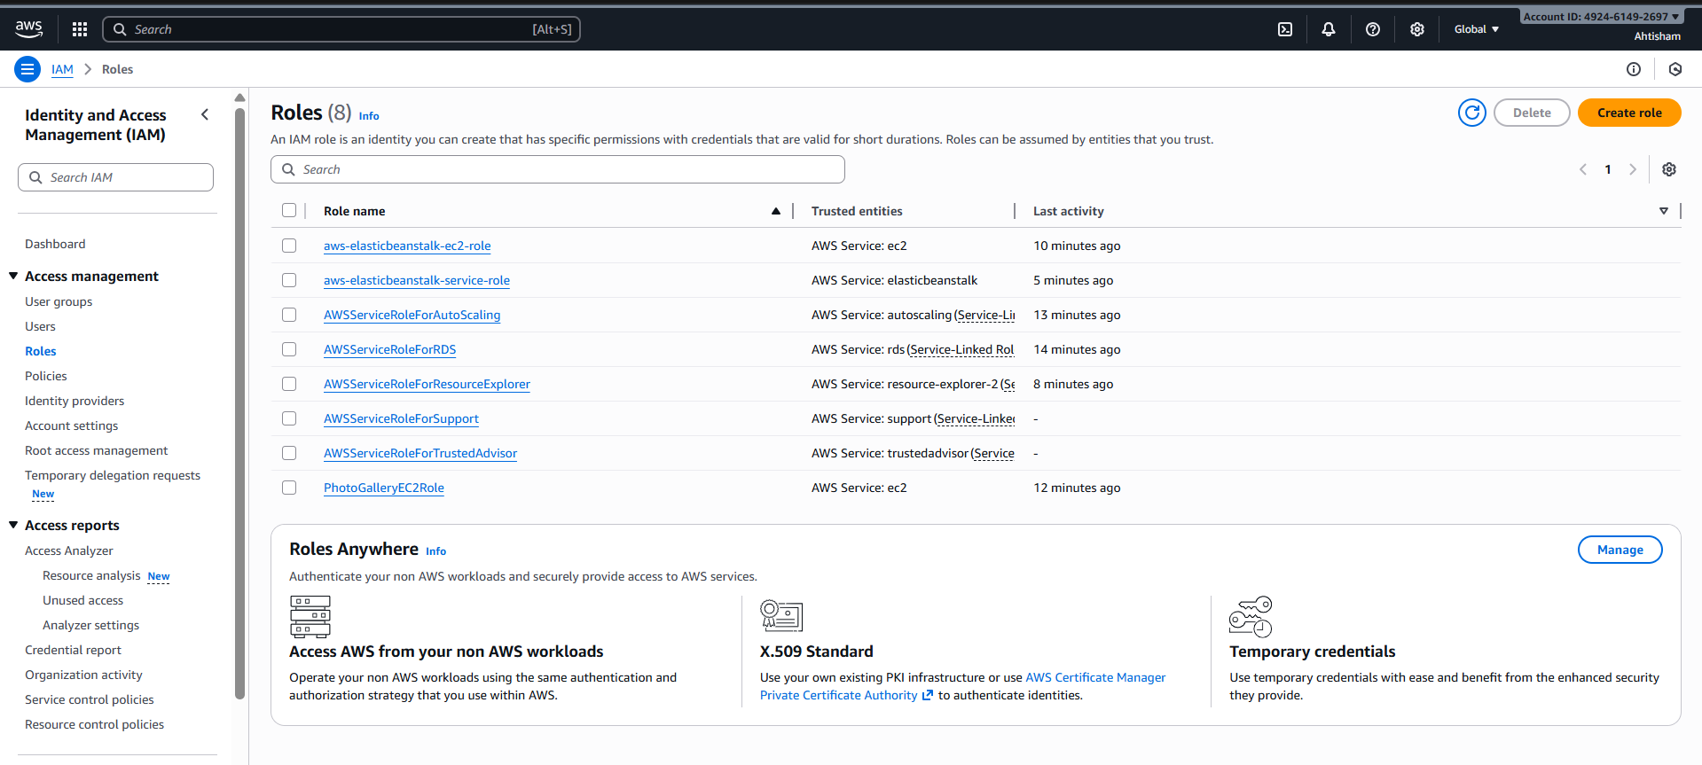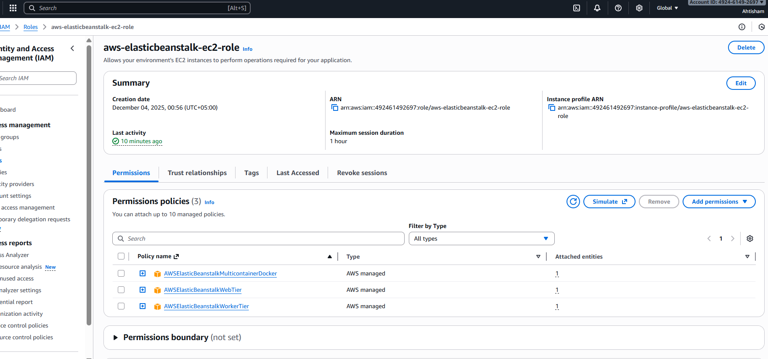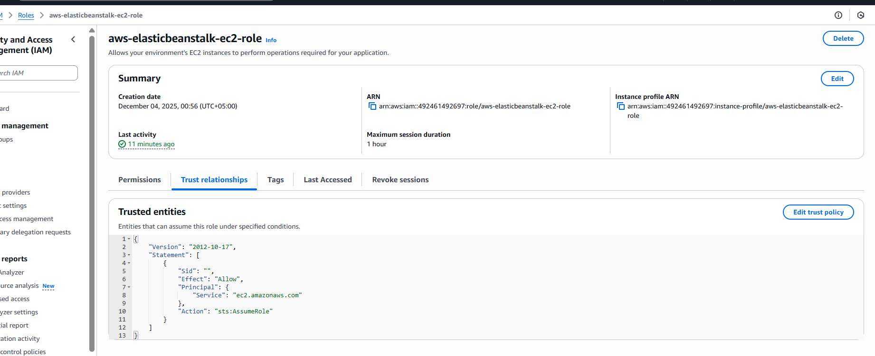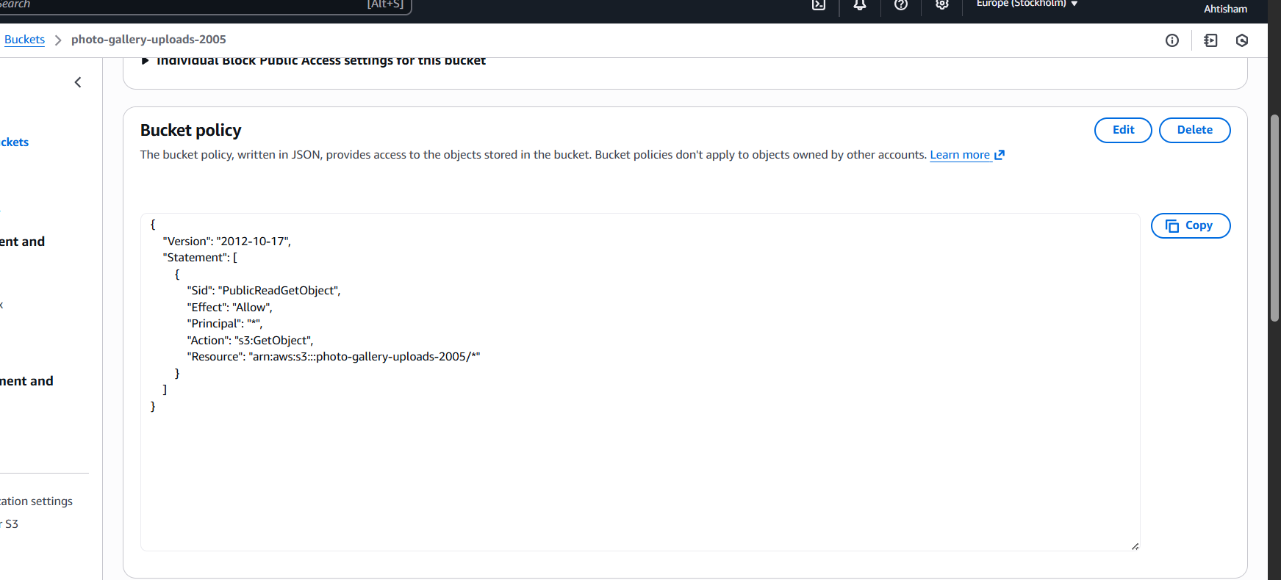

# 10. TESTING AND VERIFICATION

## 10.1 Backend API Testing

**Health Check:**

URL: http://16.16.65.200:5000/api/health

Expected Response:

{

"status": "OK",

"message": "Photo Gallery API is running",

"timestamp": "2025-12-06T..."

}

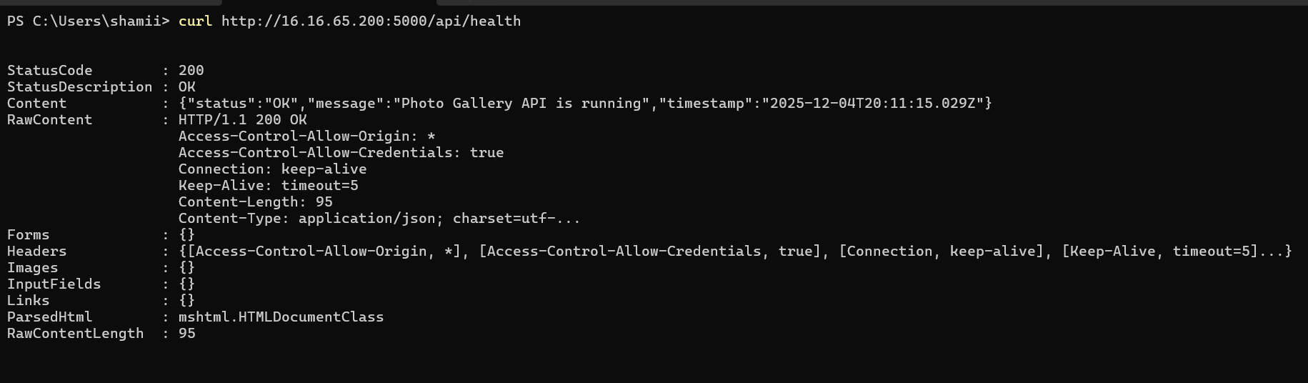

## 10.2 Frontend Testing

**Page Load Testing:**

• Homepage loads: ✓ Success

• Login page loads: ✓ Success

• Gallery page loads: ✓ Success

• Upload page loads: ✓ Success

**Functionality Testing:**

• User can register: ✓ Success

• User can login: ✓ Success

• User can upload photo: ✓ Success

• Photos display in gallery: ✓ Success

• User can create album: ✓ Success

• User can add photo to album: ✓ Success

• Navigation works correctly: ✓ Success

## 10.3 Integration Testing

**Frontend-Backend Integration:**

• API calls successful: ✓ Success

• CORS configured correctly: ✓ Success

• Authentication flow works: ✓ Success

• File upload to S3 works: ✓ Success

**Database Integration:**

• Data persists in RDS: ✓ Success

• Queries execute correctly: ✓ Success

• Relationships maintained: ✓ Success

# 11. CONCLUSION

This project successfully demonstrates the end-to-end deployment of a full-stack

web application on AWS Cloud. The Photo Gallery application showcases:

✓ Independent frontend and backend architecture

✓ Use of multiple AWS managed services

✓ Proper security configuration

✓ Scalable and maintainable code structure

✓ Production-ready deployment practices

**Learning Outcomes:**

Through this project, we gained hands-on experience with:

1. AWS Services.

2. Cloud Architecture.

3. DevOps Practices.

4. Security Best Practices.

**Challenges Faced**

**1. Elastic Beanstalk Deployment:**

• Issue: ZIP file path format incompatibility

• Solution: Used Python script to create Linux-compatible ZIP

**2. CORS Configuration:**

• Issue: Frontend couldn't access backend API

• Solution: Configured CORS middleware with proper origins

**3. S3 Upload Configuration:**

• Issue: IAM permissions for EC2 to access S3

• Solution: Created and attached IAM role to EC2 instance

**Cost Analysis**

Current Monthly Cost (within Free Tier):

• EC2 t2.micro: $0 (750 hours free)

• RDS db.t3.micro: $0 (750 hours free)

• S3 Storage: $0 (5GB free)

• Elastic Beanstalk: $0 (only pay for resources)

• Data Transfer: $0 (100GB free)

Total: $0/month (within free tier limits)

After Free Tier:

• Estimated cost: $15-30/month depending on usage  
  
  
12. SCREENSHOTS:

